Ajd’ na livo
Slavonija, Croatia

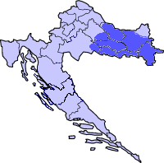
This mixed circle dance is done in the Pannonian Zone of Croatia in the regions of Slavonija, Srijem, and in the Dinaric zone in the region of Lika during holidays and festive occasions. At one time, the dance was done to the accompaniment of a two-piped wood wind instrument, tambura "samica," or bagpipe (gajde). Today it is done to the accompaniment of a tamburitza orchestra.
Other ways to spell the name of the dance is "Hajd' na levo," and "'Ajd na levo." The different spellings of the title reflect the various Croatian dialects that are spoken in the regions that this dance comes from. Other versions of this dance have been taught, and all of them are very similar.
The dance was researched by Željko Jergan in Slavonija and Baranja during 1978. This dance was presented by him at the 1995 Santa Barbara Symposium.

TRANSLATION: “Let's go left”

PRONUNCIATION: EYED nah LEE-voh

MUSIC: 2/4 meter CD: “Željko Jergan’s Dance Journey”, Band #9.

FORMATION: Closed circle, alternating M and W, facing ctr, joined in escort pos. Escort pos: R arm bent and across body at waist, L arm resting on neighbors R arm.

STEPS / Styling: Side-close: Step L to L - upper body tilts very slightly twd R (not hips) (ct 1); close L beside R - straighten body (ct 2); repeat cts 1-2 (cts 3-4).
Straight stance, soft bounces. Parts I-II-III, are faster with drmeš (shaking) style movements (flat footed steps).

METER: 4/4 & 2/4 PATTERN

INTRODUCTION 8 meas (Fast music)

4/4 CHORUS: STEP-CLOSE (Slow music)
1-2 Facing ctr and moving sdwd L - do 4 step-close steps (8 steps in all). Close but do not take wt on last step.
3-4 Repeat meas 1-2 with opp ftwk moving sdwd R.

2/4 PART I: RUN FWD & BKWD (Fast music)
1 Moving fwd twd ctr - low leap fwd on L (ct 1); small run R, L fwd (cts 1-&-2).
Note: Ftwk is flat footed
2-4 Repeat meas 1, alternating ftwk 3 more times (4 times in all), except do meas 4 in place with accent.
5-8 Repeat meas 1-4, moving bkwd.

Ajd’ na livo, Pg.2

4/4 CHORUS - REPEAT (Slow music)

2/4 PART II: BOUNCE IN PLACE (Fast music)
1 Facing ctr and dancing in place with wt on both ft - bounce on both ft with bent knees (ct 1); bounce 2 times more on heels (drmeš/shake) (cts 2-&). Note: Upper body leans slightly fwd.
2-8 Repeat meas 1. (8 bounce steps in all)

4/4 CHORUS - REPEAT (Slow music)

2/4 PART III: BOUNCE, FWD, PDB WITH STEP-HOP BKWD (Fast music)
1-2 Facing ctr and dancing in place - repeat meas 1 of Part II (2 sets of bounces)
3 Moving fwd twd ctr - do 4 small running steps fwd, R,L,R,L (cts 1-&-2-&).
4 Step R fwd (ct 1), hop on R as L lifts low in front of R (ct 2).
5 PDB - L moving bkwd: Leap L bkwd (ct 1); step R bkwd and across L (ct &); step L behind R (ct 2).
6 Step R bkwd (ct 1); hop on R as L lifts low in front of R (ct 2).
7-8 Repeat meas 5-6, moving fwd twd ctr. (PDB-L, step-hop R)

REPEAT DANCE FROM BEG ONE MORE TIME (2 times in all)

ENDING:
1-4 Repeat Chorus
1-15 Repeat Part I, twice, except last meas.
16 Stamp R-L in place
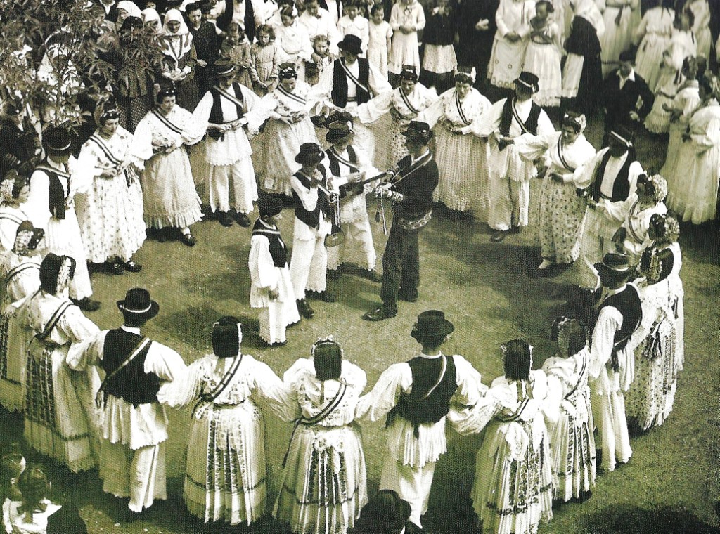

Dance notes by Željko Jergan and Dorothy Daw, 5.96

